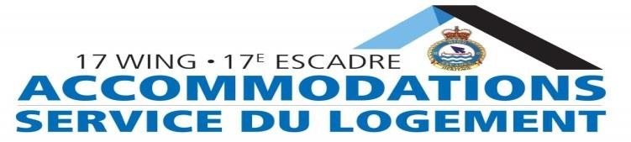

**WACCN Individual Reservation Request**

All guests staying at 17 Wing for Non-Duty purposes will be subject to pay GST for quarters. We accept the following methods of payment: Cash, Interac, Visa and MasterCard. All members and guests are required to pay their account in full upon check in. All Buildings at 17 Wing are non-smoking. No pets allowed.

All accommodation requests for more than (5) members must be submitted on a group reservation form.

Check-out time is at 1000hrs. Check-in time at 1500 hrs.

**Rations** are linked to Quarters **if supported by a FIN Code.** Questions about rations? Contact: [+MessagesRations@forces.gc.ca](mailto:+MessagesRations@forces.gc.ca) 204-833-2500 x 5435.

# General Information

|  |  |
| --- | --- |
| SN/PRI/Employee # | Rank: |
| Last Name: | First Name: |
| Home Unit: | Phone Number: |
| Email Address: | Payment Method: |
| ETA (DD/MM/YYYY & Time): | ETD (DD/MM/YYYY & Time): |

# Payment Information

|  |  |  |  |  |
| --- | --- | --- | --- | --- |
| FIN Code |  | |  | OFFICE USE ONLY |
| GL: | CC: | | Fund: | Reservation: |
| Fund Centre: | | IO/GRC: |  | Building: |
| Commitment |  | | Line: | Room: |

# Occupancy Information

|  |  |
| --- | --- |
| Number of Occupants:  *List names of all occupants in attached email* | Number of Rooms: |
| Purpose of Request: | Special Requests: |
| (Adjoining rooms, Cots, Wheelchair access, playpen, etc.) | |

Wing Accommodations - 17 WING WINNIPEG

Phone: (204) 833-2500 ext 5226; CSN: 257-5226

Fax: (204) 833-2661

E-mail: waccn@forces.gc.ca

I have read, understood and will follow the rules of Wing Accommodations and 17 Wing Winnipeg during my stay.

________________________________________________

(Guest Signature)